## Reports/ Audit / Ctrl Subs ERx Landing Time Report:

Request:

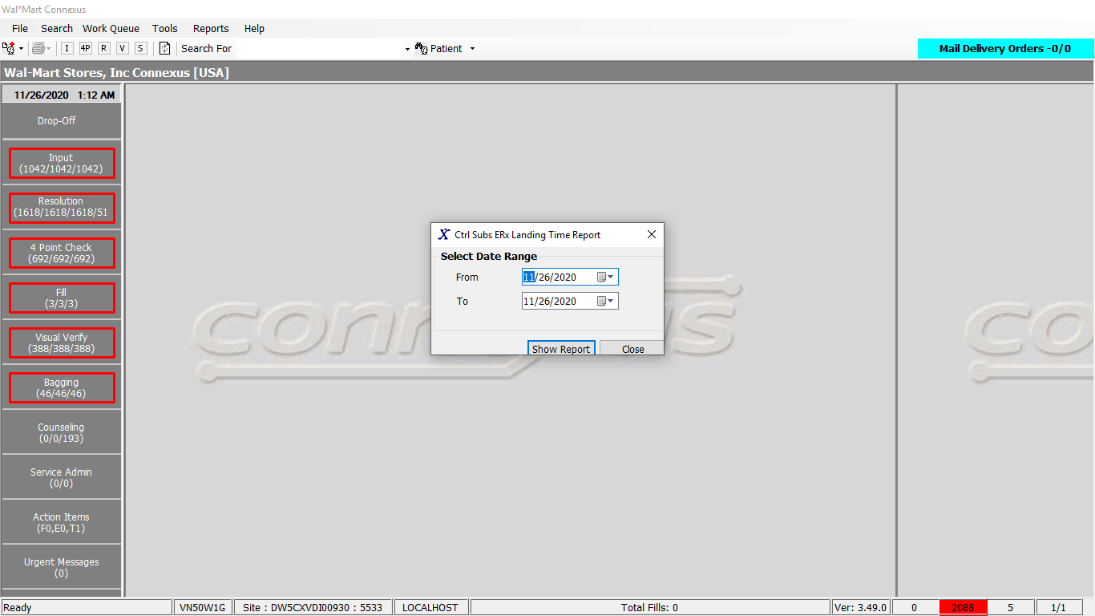

Response:

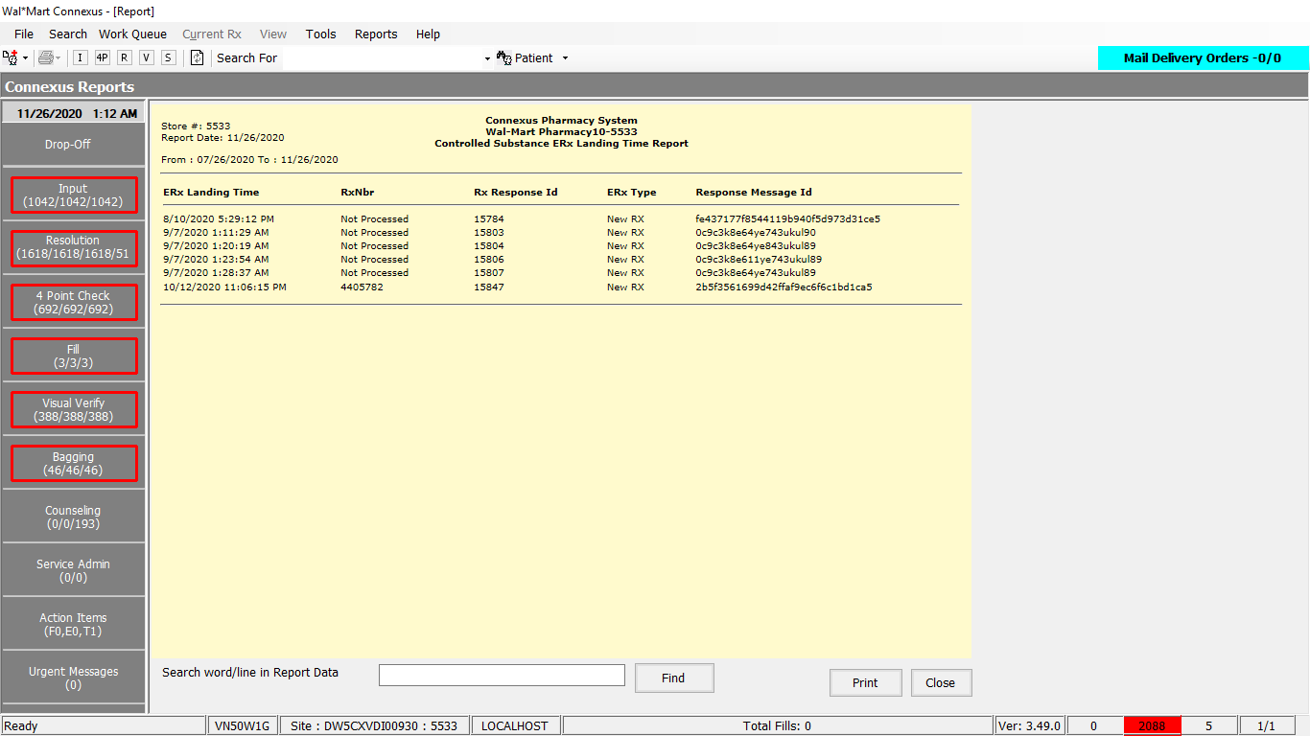

Queries

Public Const GetERxLandingTimeReport As String = " SELECT DISTINCT rer.create_ts, NVL(rx.rx_nbr, 'Not Processed') rx_nbr_txt, " &

" rer.rx_response_id, CASE WHEN rx_resp_type_code = 26200 THEN 'New RX' " &

" WHEN rx_resp_type_code = 26201 THEN 'Refill RX' END ERX_Type, " &

" rer.resp_message_id message_id FROM raw_eltnc_rx_resp rer " &

" LEFT JOIN rx_order_detail rod ON rod.rx_response_id = rer.rx_response_id " &

" AND ( rod.order_seq_nbr = ( SELECT MAX(rod1.order_seq_nbr) FROM rx_order_detail rod1 " &

" WHERE rod.order_id = rod1.order_id AND rer.rx_response_id = rod1.rx_response_id) " &

" OR (rod.status_code IN (20501, 20502) AND rer.rx_response_id = rod.rx_response_id)) " &

" LEFT JOIN rx ON rod.rx_id = rx.rx_id WHERE rx_resp_type_code IN (26200, 26201) " &

" AND DATE(rer.create_ts) BETWEEN ? AND ? AND rer.self_sign_txt = 'Y' ORDER BY rer.create_ts "

­

DAL:

Public Function GetERxLandingTimeData(ByVal siteId As Integer, ByVal startDate As Date, ByVal endDate As Date) _

As List(Of GetERxLandingTimeInfoBE) Implements IReportDAL.GetERxLandingTimeData

Using (New Tracer(ConnexusCommonConstants.ConnexusTracer))

Dim info As List(Of GetERxLandingTimeInfoBE) = Nothing

Dim parameterlist As New List(Of DbParameter)

Dim reader As IO.TextReader = Nothing

parameterlist.Add(ParameterHelper.BuildParameter("StartDate", DbType.Date, startDate))

parameterlist.Add(ParameterHelper.BuildParameter("EndDate", DbType.Date, endDate))

Using dr As IDataReader = Daab.ExecuteReader(DatabaseEnum.rx21c, siteId, ReportQueries.GetERxLandingTimeReport, parameterlist)

While dr.Read

Dim item As New GetERxLandingTimeInfoBE

If Not dr.IsDBNull(dr.GetOrdinal("create_ts")) Then

item.CreateTS = dr.GetDateTime(dr.GetOrdinal("create_ts"))

End If

If Not dr.IsDBNull(dr.GetOrdinal("rx_nbr_txt")) Then

item.RxNbrText = dr.GetString(dr.GetOrdinal("rx_nbr_txt"))

End If

If Not dr.IsDBNull(dr.GetOrdinal("rx_response_id")) Then

item.RxResponseId = dr.GetInt32(dr.GetOrdinal("rx_response_id"))

End If

If Not dr.IsDBNull(dr.GetOrdinal("ERX_Type")) Then

item.ERxType = dr.GetString(dr.GetOrdinal("ERX_Type"))

End If

If Not dr.IsDBNull(dr.GetOrdinal("message_id")) Then

item.ResponseMsgId = dr.GetString(dr.GetOrdinal("message_id"))

End If

If info Is Nothing Then

info = New List(Of GetERxLandingTimeInfoBE)

End If

info.Add(item)

End While

End Using

Return info

End Using

End Function